



Curriculum Vitae

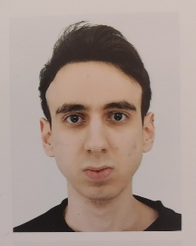
International student with high level C# programming and Unity skills.

Personal Information
First Name: Shervin Surname: Shafizad Gender: Male
Date of birth: 31/12/2002
Place of birth: Kermanshah, Iran
Current country of residence: Germany
Residency Status: Student with work permit

Education
From (2018 to 2021): Student at Shahid High school in the field of Mathematics and Physics.
From (2021 to 2024): Student at the Islamic University of Azad in the field of computer science.
From (2024- present): student at the University of Europe for applied sciences in the field of game design.

Language skills

Persian (Native Language)
Kurdish (Native Language)
English (Professional proficiency)
German (Limited proficiency)

Computer and software skills
High level C# and Unity skills (2D, 3D, mobile, pc, VR)
Basic knowledge of common programming languages such as python and Java.
Familiar with different software tools such as Photo shop, Maya, etc.

Work Experience

Developer of numerous video game projects (both solo and team projects).

More than 4 years of experience with Unity Game Engine (see my portfolio and projects website).

Four months of experience as a coding intern inside a Berlin based Company named “Thoughtfish GmbH”.

Contact Info
Germany, Berlin, Mitte,

+49 (0)1625238545
shervinshafizad entertainment@ gmail.com

Websites
Portfolio website
Projects website
Linked-in account

Hobbies
Playing video games
Practicing Taekwondo
Listening to Classical music

